**SRS Requirement for CRYPTO MYNERS :**

**Reference Links:**

* <https://user.bigminings.com/register>
* <https://www.bigminings.org/?gad_source=1&gclid=Cj0KCQjw9Km3BhDjARIsAGUb4nzg4OzzuN90uUARaJo1JOK-psw4Gg7wnIL1UGrdhNu2G8Vt6QtO5AcaAunIEALw_wcB>
* <https://e-shop-freelance.vercel.app/> (Textile Bazar)
* Username : Sarvesh999 and Password :Gupta12 (For site 1 and 2)
* Logo Image :  
  
* Loading Image :
* 

**Requirement List**

1. Landing Page / Home Page :

* Copy from Link No. 2 above till what is Bitcoin?
* Adding Testimonials (Reference Link no.3 --- Textile Bazar)
* Copy Our Partners from Link1/Link2.
* Footer same as Link1/Link2 (Discuss with me on what links to add)

2)Product Listing Page :

1. Navigation Menu : At the bottom of the page(5 icons will be shown just like below image) :  
   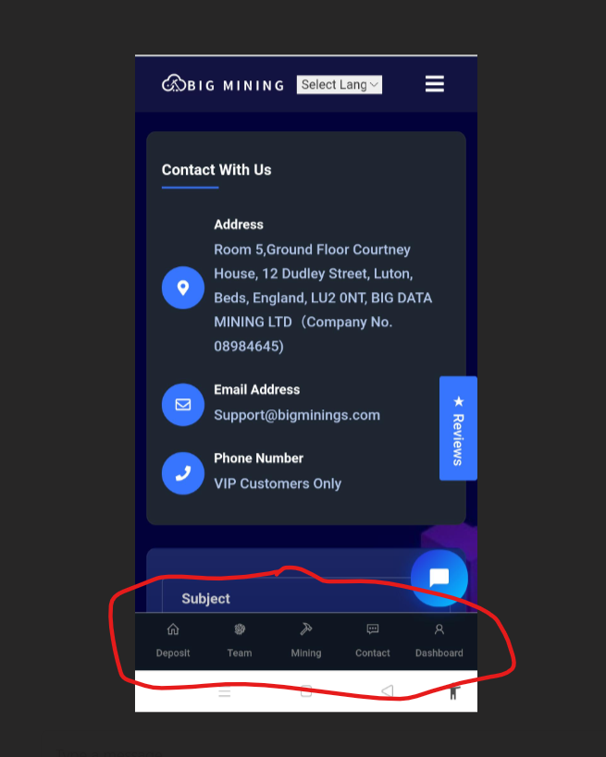
2. Explanation of Navigation Menu :  
   1. Minning -> Product Listing Page

2.Deposit ->User Machine Buy List

3.Referrals -> User Referrals List

4.Profile ->User Profile section

5.Tutorials -> This Icon will redirect us to a page which will hold several(3/4 short videos for tutorial purpose).

3)Styling of Product Listing Page:

* Reference from Link no.3 (Textile Bazar)

4)For Deposit/Referrals List design should be like this : (Discuss with me for Detailed info)

* 